All components of Hadoop 1.x :

Hadoop System is a Master-Slave architecture. Hadoop 1.x file system has 64 MB block size.  
The default replication factor in Hadoop is 3, which is configurable.

There are total 5 components in Hadoop 1.x architecture

1. Name Node (NN)  
2. Data Node (DN)  
3. Secondary Name Node (SNN)  
4. Job Tracker (JT)  
5. Task Tracker (TT)

Name Node, Data Node and Secondary Name Node are called as Storage components in Hadoop, whereas Job Tracker and Task Tracker are called as Processing components in Hadoop.

Name node is a Master Node in Hadoop  
Data Node is the slave nodes in Hadoop.  
Master Node's MR component is called as Job Tracker  
Slave Node's MR component is called as Task Tracker.

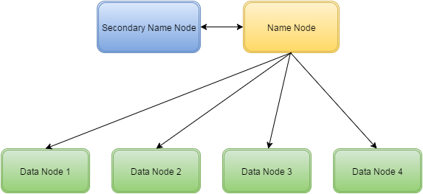

**Name Node:**

The job of name node is to decide, how to store the physical location of each and every file in blocks in the cluster. It also manages the metadata (data about the data) of the files stored in Data nodes. Name node also decides, by combining which all physical locations in the data nodes, actual file will be generated.*Namenode always stores the Metadata in* ***FSImage*** *and* ***EditLogs*** *file at regular intervals.   
This process is called as* ***Checkpoint mechanism*.**

**Data Node:**  
Data node will store the file data in blocks, as per the instructions from Name node.  
Data node will send the RPC signal at regular interval, to notify the Name node that it is alive and working.(called as Heart beat mechanism)  
  
**Secondary Name Node:**  
Secondary Name node acts as a backup for Name node.  
It stores the metadata information from Name node at regular interval as per checkpoint mechanism.  
When Name node goes down, in that case Secondary Name node comes into picture and act as a temporary Name node, till Name node becomes active again.  
  
The working of the Secondary Name Node is described in details later blogs.  
  
**Job Tracker**  
1. Job Tracker most of the times resides in the same node as of Name Node.  
2. It's job is to assign the task to the Data nodes/Task trackers  
3. It also decides the job scheduling for the data nodes/Task trackers.  
4. In case of Job failure, Job tracker decides about the rescheduling of the task on some other nodes.  
***Job Tracker is also called as Single Point of Failure (SPOF).***  
 **Task Tracker**  
Task tracker's job is to execute the task assigned by Job tracker and sends the status of those tasks to Job tracker.